**Nevis 3.0 UI components Deployment**

This document describes how to deploy the SPFX packages needed for Nevis 3.0 step by step.

1. Save the packages in a known location to upload them later:
   * nevis-branding.sppkg
   * hub-site-nav.sppkg
2. open the tentant app catalog
3. open the apps for SharePoint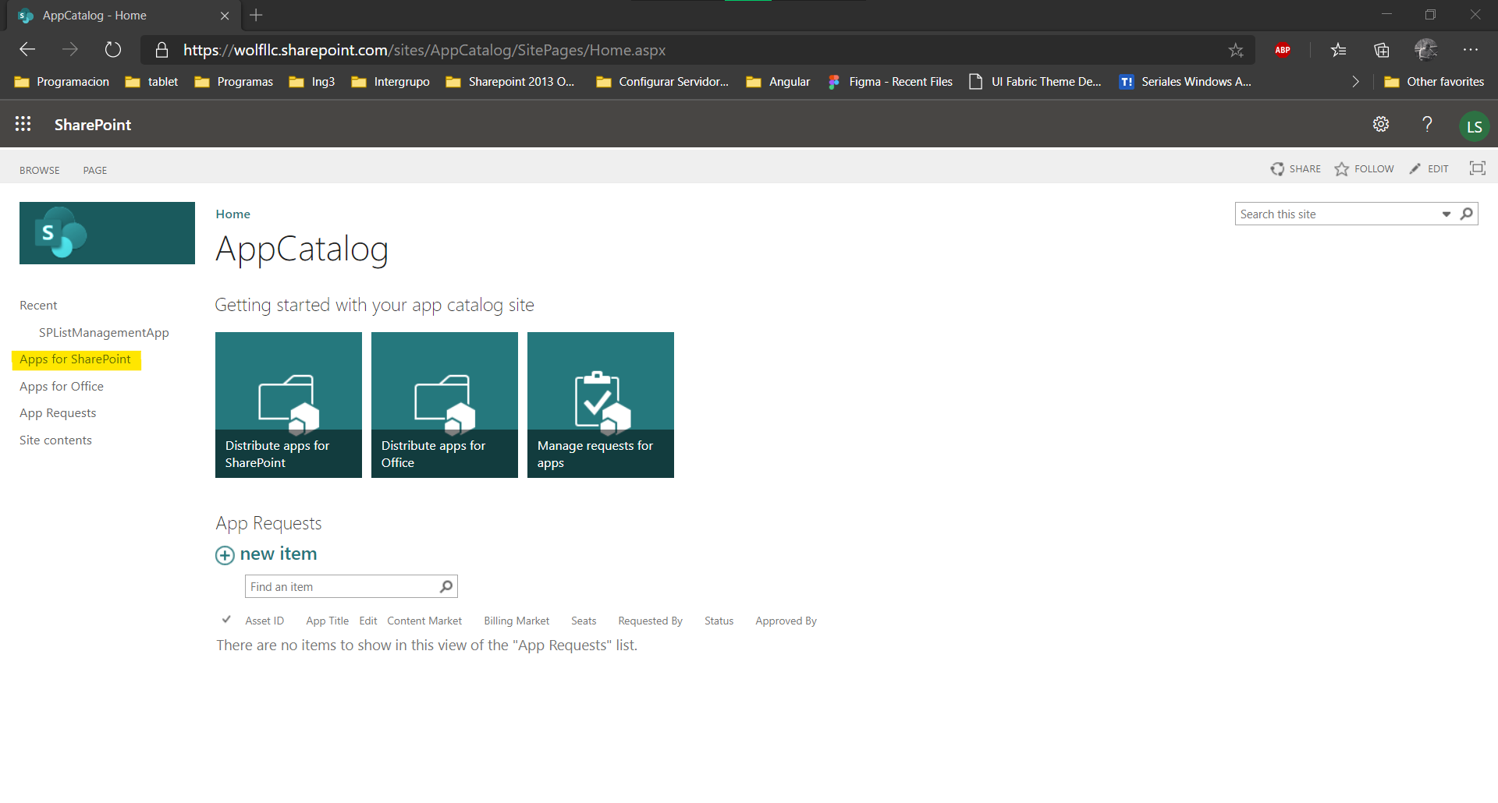
4. select the upload option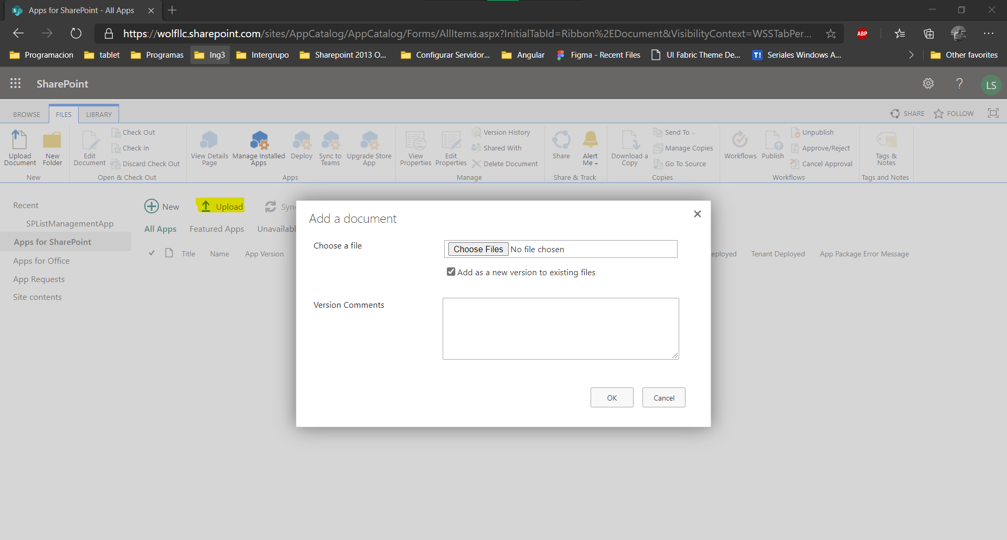
5. make sure the option of “Make this solution available to all sites in the organization” is not checked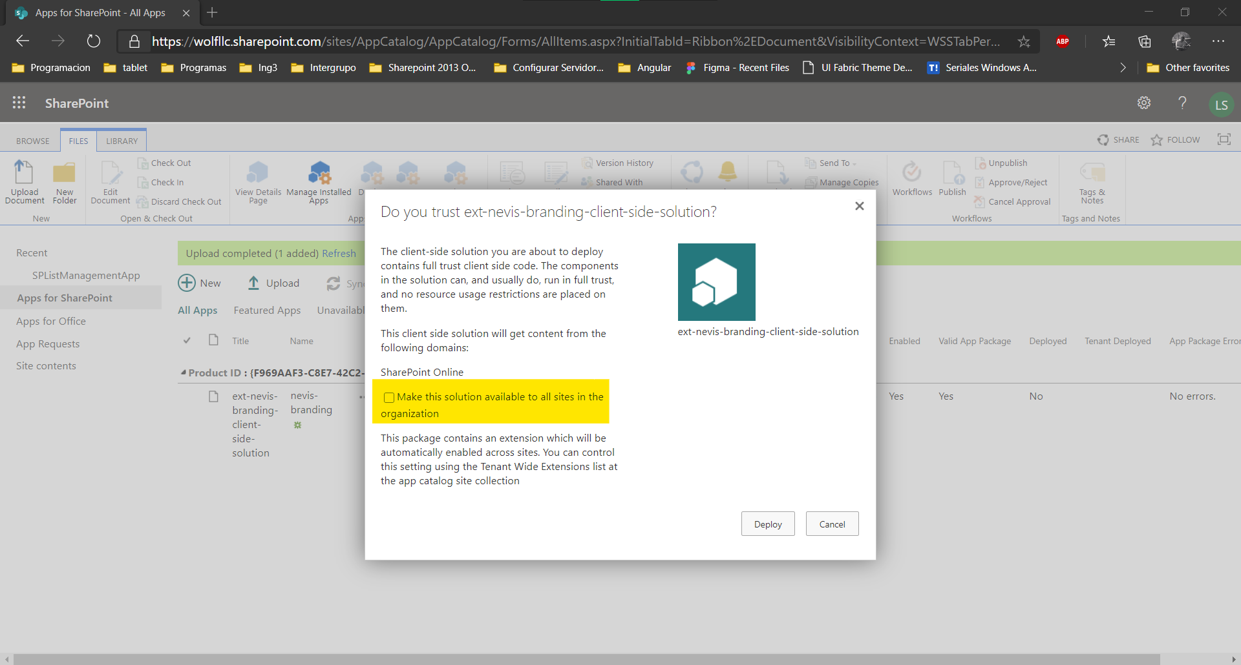

and after that clic the deploy button.

1. Repeate the process with the other package.

After this procedure the apps are available for install in the corresponding sites.